Membership No: office use only

National Federation of Young Farmers’ Clubs Membership Form 2019/20

Section 1 – Essential Information

Title: First Name: Surname:

Preferred Name:

Date of Birth: Age:

I identify my gender as:

Male : Female: Self Identify:
Please use this space if you wish to self identify

Address:
Postcode:

Home Tel no: Member’s mobile no:

Member’s email address:

Club:

(U18 members only)
Parents name: Parent’s email address:

Section 2 – Health & Wellbeing Information

To ensure you/your child is able to participate and enjoy the activities and opportunities that YFC provides we ask that you complete the following health information and details of dietary requirements, medical conditions, disabilities or special educational needs (SEN)

Do you have any of the following?
Please provide additional information

Health conditions Yes/No
Disability Yes/No
SEN Yes/No
Allergies Yes/No
Other additional needs Yes/No
Dietary requirements Yes/No

Any other relevant information we need to be aware of (e.g. Medication):
Please provide additional information

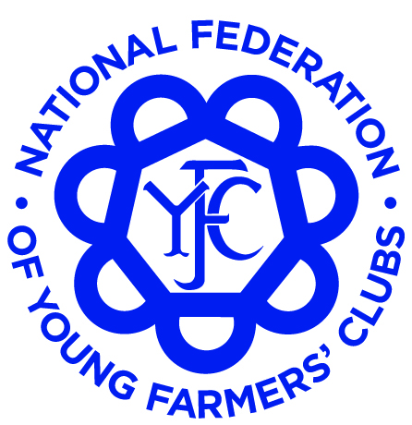
www.nfyfc.org.uk
Find Us

Section 3 – Emergency Contact Details

Emergency Contact Details (ICE) (2 for U18 year olds and at least one for over 18 year olds)

Name: Relationship:

Main contact number: Alternative phone number:

Name: Relationship:

Main contact number: Alternative phone number:

Section 4 - Marketing Preferences

As part of your membership of NFYFC, we will keep you informed of relevant membership news, events and activities through our communication channels both online and in print. These include the NFYFC membership magazine Ten26 and a monthly e-newsletter called the YFC Buzz that is sent to your email address. Otherwise, NFYFC and your county will only use your email to contact you from time to time about opportunities that may be available to you as part of your membership or in relation to your role within YFC. Your details will not be shared with 3rd parties for marketing purposes.

So we can ensure you receive these membership publications, can you confirm you are happy for us to send these to you.

Would you like to receive the membership magazine Ten26 to your home address? Yes/ No
Would you like to receive the email newsletter YFC Buzz via email? Yes/ No

Do you wish to receive Ten26 in? English: Welsh:

Member Signature: Date:

Parent/Guardian Signature: Date:

Office use only:

Member Paid
Privacy notice
For more information on our privacy notice visit the National Federation of Young Farmers’ Clubs

Website at: http:\\www.nfyfc.org.uk\privacy

